SQL Learning



Nithish Gowda

**Functions in SQL :**

**Aggregate function**

**String function**

**Date and Time Functions**

**Mathematical function**

**Conditional function**

**Window / Analytical function**

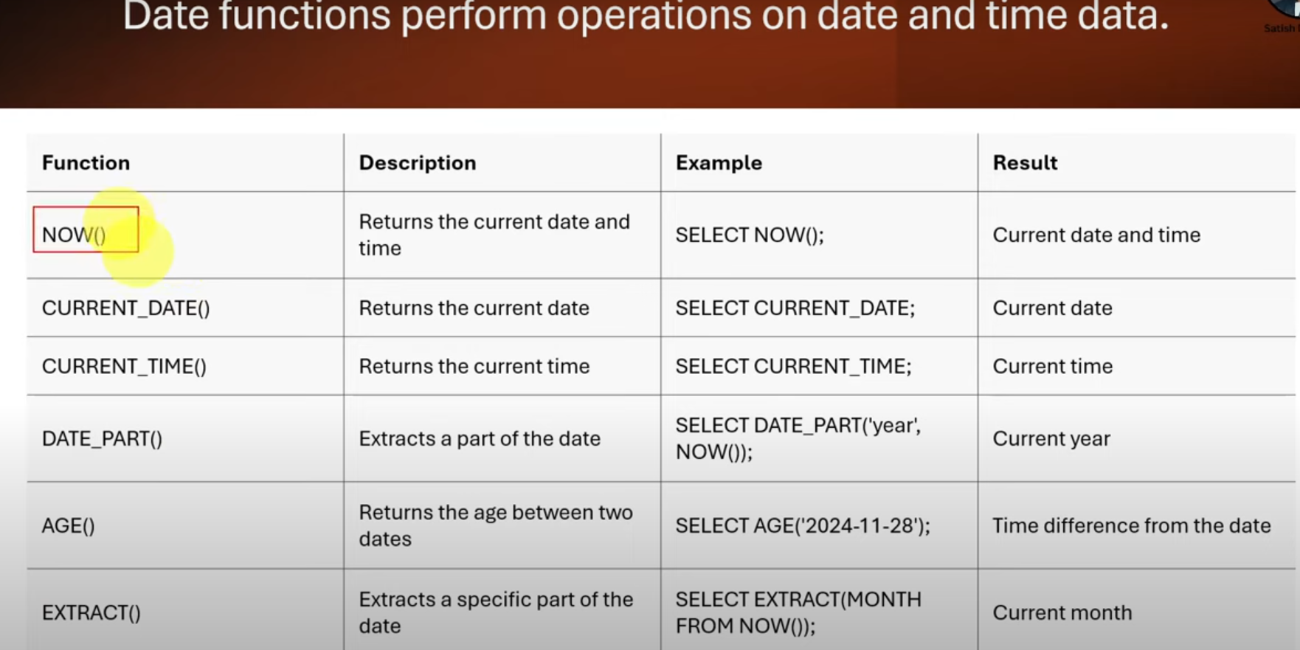

---date time fucntions -----

----now()- get current date and time---

select now() as current_date;

--current date --- get current date

select current_date as to_date;

select added_date,current_date,(current_date-added_date) as days_diff

from products;

--- extract- extratc parts of date-- teh year,month,day from the adde_date column---

select product_name,

extract(year from added_date) as year_addde,

extract(month from added_date) as month_addde,

extract(day from added_date) as day_addde

from products;

-----age() calculate age between dates

--calculate teh time differences between added_date and today's date

select product_name,

age(current_date, added_date) as age_since_Added

from products;

-----to_char()-format dates as strings

---format added_date in a custom format(DD-MM-YYYY)

select product_name,

to_char(added_date, 'DD-MM-YYYY') as age_since_Added

from products;

select product_name,

to_char(added_date, 'YYYY') as age_since_Added

from products;